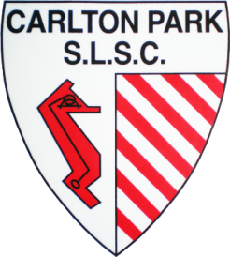 | Carlton Park Surf Life Saving Club Inc.  PO Box 44  DODGES FERRY 7173  ABN 28 606 295 281  Email: carltonparkslsc@slst.asn.au  Website: www.carltonparkslsc.com.au

NOMINATION FORM
CPSLSC COUNCIL/COMMITTEE SEASON 2019-20

I would like to nominate ……………………….…………………………………………..for

the position of ………………………...…………………………………… on the CPSLSC

Council (Committee) for Season 2019-20.

Nominated By:

Name:………………………………………..………..
Signature:……………………………..………………
Date:……../……../…….

Seconded By:

Name:………………………………………..………..
Signature:……………………………..………………
Date:……../……../…….

Accepted by Nominee:

Name:………………………………………..………..
Signature:……………………………..………………
Date:……../……../…….

# All persons signing this nomination form must be a financial member of Carlton Park Surf Life Saving Club. Nomination forms should be submitted to the Secretary at least 1 hour prior to the AGM. If nominations are not received in writing for any particular position, the meeting may nominate and appoint same. Nomination forms can be submitted via email to the Secretary at carltonpark@slst.asn.au

